

Williamson Road Child Care Centre

**ADMISSION PROCESS**

Williamson Road Child Care Centre is licensed for a maximum of 90 School Age children and 26 Junior/Senior Kindergarten. The admission process begins when a parent fills out an application form for their child. The applications are placed in order of date the application was received. If the child has not yet reached Junior Kindergarten, then the applications will be kept separate and filed by each year the children reach Junior Kindergarten. Please see Wait List Policy on reverse for more details.

**INCLUSION POLICY**

Williamson Road Child Care accepts all children regardless of abilities. We are willing to include all children in all aspects of our program. We believe that by providing experiences based on children’s needs, we will help them achieve their fullest potential and are committed to the learning and growth of all children. Staff are willing to access additional supports for the children in our program when necessary. We believe that positive social interactions foster growth and we strive to provide such an environment.

**INITIAL INTERVIEW**

Children must be enrolled in Williamson Road P.S. in order to be accepted into the child care. When a space becomes available the parents will be contacted and asked to come in for a tour and an initial interview. The staff will use this opportunity to meet the child and gather information that is pertinent to the child’s care. The Director will review our Family Handbook containing information regarding our Policies and Procedures.

If at the time of the meeting, a parent informs the Director that the child has an identified special need, the staff will gather any information from the parent, and may contact our Special Needs Consultant to ensure that the child’s needs can be met in our program.

If after meeting with the family, and consulting with the Special Needs Consultant, it is determined that WRDCC may not be the best option for the child, WRDCC will try to help the parent find a suitable alternative.

The wait list will be made available in a manner that maintains the privacy and confidentiality of the children listed. However, we will allow information available to the family that is requesting their position on the wait list.

*Once families have been accepted into either Kindergarten/School age program. If at any point later, if the family chooses to withdraw from the program. Families must be aware that you forfeit your spot and later wish to return, families will be put back on the wait list and subject to the process of enrollment priority.*

___________________________________________________________________________

24 Williamson Road. Toronto ON M4E 1K5 Telephone: (416) 691-8861

E-mail: info@wrdcc.org

# **WAIT LIST POLICY**

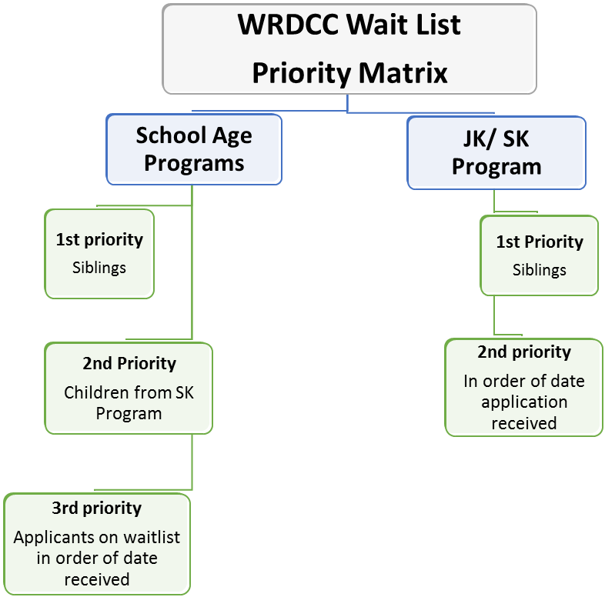

**Our Wait List Policy States:**

Every Application to WRDCC is placed in order of date received. Siblings are given priority and are moved to the top of the each wait list each September. Upon registration, please request to be placed on both our Kindergarten and our School Age Wait List.

***A Sibling priority is:* Two children from the same family who will be attending the Centre in the same school year. Should there be more siblings than there are spaces, then sibling applications will be placed in order of date application was received. EACH Sibling MUST have an application to be put on the waitlist.**

**JK/SK rooms**: After the sibling priority, any remaining spaces will be offered to the applicants in order of date received from the remaining wait list.

**School Age Rooms:** After the sibling preference, any remaining spaces will be offered to children in the SK room, followed by applicants on the wait list in order of date received.

Applicants on the wait list are contacted 2x over a period of two weeks and must express interest to remain on the wait list each September. If there is no response, the application will be removed from the wait list.

For privacy and confidentiality purposes please speak to the Director of the centre to ascertain where your position is on the waitlist.

**This wait list policy is reviewed yearly with the staff/students/volunteers**

**Any disputes regarding placements will be determined by the Board of Directors in its sole and absolute discretion.**

WILLIAMSON ROAD CHILD CARE CENTRE APPLICATION FORM

Please print clearly.

**Child’s Name**: __________________________________________ **M F Known as:**__________

(last) (first) (middle)

Home Address: _____________________________ ______________Postal Code_________________

Telephone Number: ______________________________ Birth date: ___________________________

**Parent/Guardian Name**: _______________________________ Home Address: _______________________

Home phone: _____________________________________ Cell phone: _______________________

Employer: _________________________________Business Address: __________________________

Bus. Telephone Number: ___________________________ Email: _______________________________

**Parent/Guardian Name**: __________________________________Home Address: _______________________

Home phone: ___________________________________ Cell phone: __________________________

Employer: ________________________________ Business Address: ___________________________

Bus. Telephone Number: _____________________________ Email: ______________________________

**SIBLINGS**

(Please note that siblings of presently enrolled children in the child care and who are registered a year in advance

of their enrollment date, receive priority and move to the front of the list each September.)

Name: __________________________________________ Age: __________ Sex: _________

Name: __________________________________________ Age: __________ Sex: _________ **HEALTH INFORMATION**:

Child’s Doctor: _____________________ Doctor’s Telephone Number: ______________

Doctor’s Address: ______________________Child’s Health Card#: _________________

Child’s Drug or Food Allergies: ______________________________________________________________________________________________

Other Health Concerns or Special Diets: ______________________________________________________________________________________________

History of Communicable diseases (e.g. Chicken Pox):­­­­­­­­­­­­­­­­­ ______________________________________________________________________________________________

**EMERGENCY CONTACT** (other than parent):

Name: _________________________________Relationship to child: _________________

Address: _____________________________________________________________________

Home phone: _______________________________Business Phone: _________________

**REGISTRATION INFORMATION**

Date you wish care to commence: ___________________

Please check which age groups you are submitting: Junior/Senior Kindergarten Care or School Age Waitlist.

____ JK _____ SK ____SCHOOL AGE

Will you require subsidy from Toronto Children’s Services? Yes ____ No______

Date of Application: _____________________Signature: ___________________________

# **FOR CHILD CARE USE ONLY**

Date Application Received: ____________________ Application Received by: ______________

Date Child Commenced Care: ____________________ Date Child Departed Care: ____________

Date Application Withdrawn: _____________________________________________________